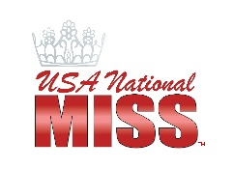
Jr. Princess, Princess, Preteen Interview Bio Sheet

Name:____________________________________________________________________________________
Local Title:_____________________________________________Jr. Princess Princess Preteen

School:_________________________________________________________________________________
Hobbies:________________________________________________________________________________

________________________________________________________________________________________

Goals/Aspirations: _______________________________________________________________________________________

________________________________________________________________________________________

3 reasons why you should be given the opportunity to represent SC/NC nationally:
1)______________________________________________________________________________________

2) ______________________________________________________________________________________
3)______________________________________________________________________________________

What would you do to positively impact others, society or the earth through UNM’s INSPIRE platform if you are crowned?:

________________________________________________________________________________________

________________________________________________________________________________________

Fun Fact: ________________________________________________________________________________

Who Inspires You: ________________________________________________________________________

