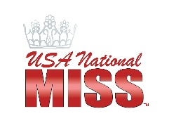
Jr. Teen, Teen, Miss Interview Bio Sheet

Name:____________________________________________________________________________________
Local Title:_____________________________________________Jr. Teen Teen Miss

School/Work: ____________________________________________________________________________

Goals & Aspirations: ______________________________________________________________________

Marketing plan to promote the state pageant if you win the state title: ________________________________

________________________________________________________________________________________

________________________________________________________________________________________

3 reasons why you should be given the opportunity to represent our state nationally:
1)______________________________________________________________________________________

2) ______________________________________________________________________________________
3)______________________________________________________________________________________

What would you do to positively impact others, society or the earth through UNM’s INSPIRE platform if you are crowned?: ____________________________________________________________________________

________________________________________________________________________________________

What does Positively Empowered mean to you?: _______________________________________________

________________________________________________________________________________________

Hobbies:________________________________________________________________________________

Fun Fact: ________________________________________________________________________________
________________________________________________________________________________________

