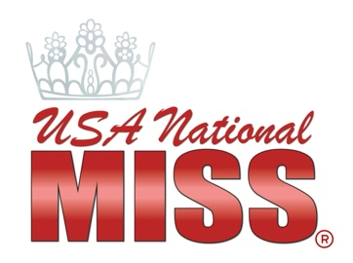

NATIONALS FORUM SCHEDULE

FRIDAY | Event | Location & Additional Info
 | Private coaching lessons all day
 | Headshots with Carlos all day
5pm | Forum shopping begins | Meet ASHLEYlauren & shop from our forum vendors
7pm-9pm | Forum Check-In & Welcome Reception | Jr. Ballroom & Terrace
SATURDAY
 | Private lessons, wardrobe shopping and headshots all day
9am-11am | Jr. Division Walk and Talk Session  9am-9:30am Layilah Nasser- Gown  9:30am-10am Michaela Abelgas- runway  10am-10:30am Amanda Moreno-  Interview platform/service  10:30am-11am Jorge Esteban-  Interview communication | Windward A/B
10am-1:35pm | Sr. Division Mock Interviews | Jr. Ballroom
2pm-4pm | Sr. Division Walk and Talk Session  2pm-2:30pm Layilah Nasser- gown  2:30pm-3pm Michaela Abelgas- runway  3pm-3:30pm Amanda Moreno  Interview platform/service  3:30pm-4pm Jorge Esteban-  Interview communication | Windward A/B
2:30pm-4:20pm | Jr. Division Mock Interviews | Jr. Ballroom
6pm-7pm | Camp INSPIRE Event | Jr. Ballroom
SUNDAY
8am-12pm | Private lessons, wardrobe shopping and headshots
8am-10am | Sr. Division Forum General Session | Windward A/B
10am-12pm | Jr. Division Forum General Session | Windward A/B

